Grand View Volunteer Fire Department
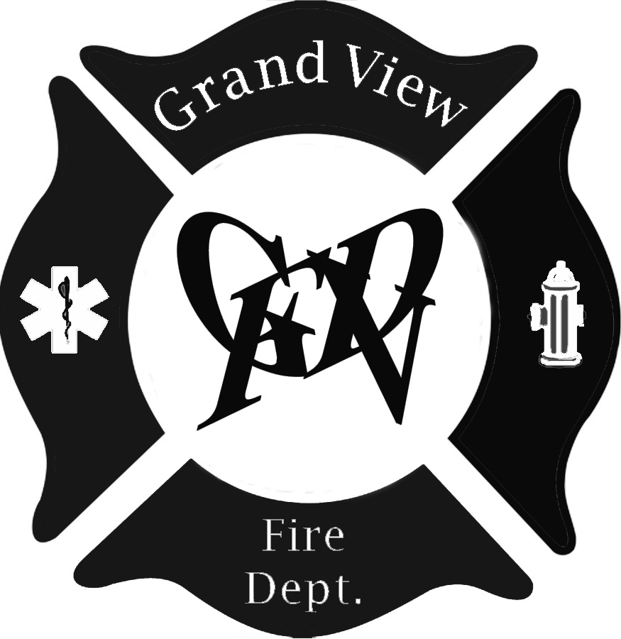

“Firehouse” Scholarship Application

(The Grand View Volunteer Fire Department assures that all information will be kept in confidence and will be used only in determining the recipient of their scholarship. Your application will be returned upon request)

Name: ____________________________________________

Name of school/schools to which you have applied for admission:
___________________________________________________________
Have you been accepted at the above school/schools? ___ yes ___ no
(If yes, please submit written document verifying your being accepted.)

What is your intended major or emphasis?
___________________________________________________________________________

What courses have you taken at Drummond High School to prepare you for the above major or Emphasis?
Subject Credits Subject Credits
__________________________ ____ ______________________________ ____
__________________________ ____ ______________________________ ____
__________________________ ____ ______________________________ ____
__________________________ ____ ______________________________ ____

Please check any examples of “service” to the school while attending high school and record the year or years you were involved. Use (1) for freshman, (2) for Sophomore, (3) for junior and (4) for senior.
Activity Years
_____ Band _____ Student Government
_____ Choir _____ Class Officer
_____ Drama _____ President
_____ Forensics _____ Vice President
_____ Yearbook Staff _____ Secretary
_____ Newspaper Staff _____ Treasurer

Sports (include spring ‘21)
________________________ __________________________
________________________ __________________________
________________________ __________________________

Clubs
________________________ __________________________
________________________ __________________________

2
_____ Student Aide No. of Quarters_____________
_____ Other __________________________________________

Please record any examples of “service” to the community while attending high school:
Activity (community, church) Year/Years
________________________________________________________________ __________
________________________________________________________________ __________
________________________________________________________________ __________
________________________________________________________________ __________
Please list any awards that you have received:
________________________________________________________________ __________
________________________________________________________________ __________

Please rate yourself in regard to motivation (circle one with 5 being the highest)
1. Classroom Participation: 1 2 3 4 5

2. Preparation: 1 2 3 4 5

3. Classroom performance: 1 2 3 4 5

4. Promptness: 1 2 3 4 5

5. Describe your life’s goals and explain how furthering your education will help you achieve them. (A separate page may be used if desired)

6. Tell us your thoughts about how the Pandemic has affected your education: (A separate page may be used if desired)

Please return this application along with a transcript of your school record and scholastic aptitude test (ACT) results before May 1, 2021 to:

Grand View Volunteer Fire Department
C/o Jack Hoiby
22475 Sunset Acres Lane
Grand View, WI 54839

