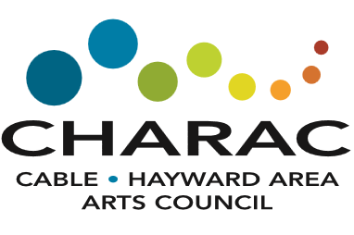
Application

Scholarship for the Arts

Submission Deadline: March 10, 2021
Applicant Name: |  |  |  |  |  |  | Date of Birth:
Home Mailing Address | Street:
City, State, Zip Code:
Phone #: |  |  |  |  | Personal email:
High School:
High School Counselor:
High School GPA:
School you may attend in Fall 2020? (name, city, state):
Have you been accepted? |  |  | Yes |  | Conditional |  |  | Not Yet
Will you be a full-time student? |  |  | Yes |  | No
Your Art Category |  |  | Visual Arts |  | Performing Arts |  | Literary Arts |  |  | Other
Formal and informal arts training, classes, workshops, internships, etc.

Activities, exhibitions, performances, recitals, etc.

How did your arts training and activities lead you to your course of study?

Describe your anticipated course of study.

Please email completed application to: cablehaywardarts@yahoo.com or mail to
P.O. Box 182, Cable, WI 54821

